Table of Contents
- Abstract
- List of Abbreviations
- List of Tables and Figures
- Introduction
  - Introduction to Language
  - The Problem Statement
  - Challenges of identifying language from speech
- Literature Survey: Unveiling Languages from Speech Samples with Embeddings
  - Purpose
  - Key concepts
  - State-of-Art pre Trained Models: Revolutionizing Various Tasks
- Methodology
  - Data Acquisition and Preprocessing
  - Pre-Trained ECAPA – TDNN Model
  - Anomaly Detection: OC-SVM A Deep Dive
    - Core Concepts
    - Key Components
    - How it Works
  - Support Vector Machine(SVM) for Classification: A Deep Dive
    - Core Concepts
    - Key Components
    - How it Works
- System Development
  - Hardware
  - Software
- Dataset and Feature Selection
- Experiments Performed
- Results
- Conclusion and Future Work

Abstract
Language Identification refers to the process of detecting the language(s) of the speech or in text in the document based on the script used for writing and observing the diacritics particular to a language. This research area has always fascinated researchers as early as 1970 and till now due to varied applications and increased demands of this field. In this project we basically focus on identifying language from spoken audio samples. The method leverages a two-stage classification process to achieve accurate language recognition while mitigating the impact of outliers. Key stages include: Embedding extraction, Outlier Detection, Language Classification.
We utilize the ECAPA-TDNN architecture from SpeechBrain, a pre-trained deep learning model, to generate audio embeddings from the speech samples. These embeddings represent the speech data in a high-dimensional space, capturing essential characteristics relevant to language identity. An OCSVM is employed as the first stage. It is trained solely on speech data from known languages. New speech samples are mapped into the embedding space. The OCSVM identifies and discards outliers (potentially containing noise or non-speech elements) that fall outside the expected boundary of known languages. The remaining speech samples, deemed likely to represent actual speech from known languages, are passed to a standard SVM classifier. This SVM, trained on labeled speech data from multiple languages, classifies the samples into their respective languages based on the informative embeddings.
The project will evaluate the effectiveness of this multi-stage approach using appropriate metrics like accuracy, precision, recall. We will analyze the impact of the OCSVM stage in improving the accuracy of the final language classification by the SVM.

List of Abbreviations

- LID: Language Identification
- MFCCs: Mel-Frequency Cepstral Coeffients
- SVM : Support Vector Machine
- NLP: Natural Language Processing
- ECAPA – TDNN: Emphasized Channel Attention, Propagation and Aggregation Time Delay Neural Network
- SE: Squeeze and Excitation
- OC-SVM: One Class Support Vector Machine
- CPU: Central Processing Unit
- GB: Giga bytes
- RAM: Random Access Memeory
- SSD: Solid State Drive
- HDD: Hard Disk Drive
- OS: Operating System
- AMD:
- PCA: Principal Component Analysis
- t-SNE: t-Distributed Stochastic Neighbor Embedding
- OOS LID: Out of Set Language Identification
- XGBoost eXtreme Gradient Boosting
- UMAP: Uniform Manifold Approximation and Projection
- OOS LC: Out of Set Language Classification

List of Tables and Figures

- Table 1. List of Inset and Outset Languages
- Table 2. List of Languages and their Threshold Probability
- Table 3. Outset Languages with their no of Samples identifies as outliers
- Fig 1. In-set Languages Visualisation using 2 PCA Components
- Fig 2. In-set Languages Visualisation using 2 t-SNE Components
- Fig 3. Outlier Dectection using PCA Components
- Fig 4. Outlier Detection using t-SNE Components
- Fig 5. Gaussian Distribution for probabilities of each Language
- Fig 6. Confusion Matrix for Testing set.
- Fig 7. Probability Distribution for each Outset Language

2

- Introduction
  - Introduction to Language
Language, a system of conventional spoken, manual, or written symbols by means of which human beings, as members of a social group and participants in its culture, express themselves. The functions of language include communication, the expression of identity, play, imaginative expression, and emotional release.
The scientific study of language is called linguistics. It explores various aspects like:
- Phonology: The sound system of a language, analyzing how sounds are produced and combined.
- Morphology: The structure of words, including prefixes, suffixes, and how words are formed.
- Syntax: The rules for arranging words into sentences and phrases.
- Semantics: The meaning of words and sentences, including how context affects meaning.
- Pragmatics: How language is used in specific contexts to achieve communication goals.
There are thousands of languages spoken worldwide, each with unique features and histories. Languages can be categorized into families based on shared origins, like the Indo-European family which includes English, Spanish, and Hindi. Languages are constantly evolving, adapting and changing over time.
1.2 Problem Statement
Language identification (LID) from speech samples presents a captivating challenge at the intersection of computer science and linguistics. This technology aims to determine the language spoken in a given audio clip automatically.
Traditional language identification systems struggle with unknown languages, assigning them to known categories and causing errors. Open-set language identification tackles this challenge. It aims to develop a system that can identify known languages and flag those it hasn't encountered before. This is particularly difficult due to the vast number of human languages and the limited data available for less common ones. However, overcoming these challenges would significantly improve the accuracy of language processing tasks by enabling them to handle a wider range of languages. We would be mainly focusing on open set category where we need to describe whether the given language belongs to the given set of languages or not. If not , then it must be able to tell that its an unkown language. If present then it must be bale to tell the language label.
1.3 Challenges of Identifying Language from Speech
Despite its potential, speech-based LID faces certain challenges:
- Similarities Between Languages: Languages often share characteristics, making it difficult for computers to differentiate between them definitively. Loanwords (words borrowed from another language) and dialect variations within the same language can further complicate the task.
- Non-verbal Cues and Background Noise: Speech samples can be influenced by factors beyond language itself. Accents, speaker characteristics, and background noise can pose hurdles for LID systems, requiring them to be robust to such variations.
- Code-switching: The practice of mixing languages within a single conversation adds another layer of complexity. LID systems need to be able to handle these situations and accurately identify the underlying languages used.
Despite significant advancements, several challenges remain. Developing LID systems that work effectively with limited data for less common languages is a critical area of research. Data augmentation techniques and transfer learning from high-resource languages are promising approaches to address this issue. Additionally, handling code-switching and recognizing specific dialects or accents remain ongoing challenges.

2. Literature Survey: Unveiling Languages from Speech Samples with Embeddings
2.1 Purpose
Language identification (LID) from speech samples plays crucial role in bridging communication gaps across languages. This survey delves into the current landscape of speech-based LID, exploring the feature extraction techniques, classification models, and emerging trends that shape this domain.It aims to explore the field of language identification (LID) using speech samples. The goal is to understand the current state-of-the-art techniques, identify key challenges, and explore potential future directions for this technology.
2.2 Key Concepts:
- Language Identification (LID): The automatic process of determining the language spoken in a speech sample.
- Speech Features: Informative characteristics extracted from speech audio, such as Mel-Frequency Cepstral Coefficients (MFCCs) or embeddings learned by deep learning models.
- Classification Models: Algorithms that learn to distinguish between different languages based on extracted features. Examples include Support Vector Machines (SVMs) and deep neural networks.
- Deep Learning: A subfield of machine learning using artificial neural networks with multiple layers to learn complex representations from data.
- Embeddings: Compressed representations of speech data learned by deep learning models, capturing essential features for language identification.
2.3 State-of-the-Art Pre-trained Models: Revolutionizing Various Tasks
Pre-trained models have revolutionized various fields within machine learning, including natural language processing (NLP), computer vision, and speech processing. These models are trained on massive datasets and capture general-purpose knowledge that can be fine-tuned for specific tasks, significantly improving performance compared to training models from scratch. Here's an overview of the current landscape
Speech Models:
- wav2vec 2.0: This pre-trained model, based on a transformer encoder, learns general audio representations from raw waveforms. It can be fine-tuned for various speech processing tasks, including speech recognition, speaker identification, and language identification.
- s This model family leverages pre-trained embeddings and a time delay neural network architecture to capture temporal information in speech. ECAPA TDNN models excel in tasks like language identification and speaker identification, particularly when computational efficiency is a concern.

3. Methodology
Language identification (LID) systems aim to automatically determine the spoken language from a speech sample. Here's a breakdown of the typical methodology involved:
3.1 Data Acquisition and Preprocessing:
VoxLingua107 is a valuable open-source dataset for training language identification (LID) models. The dataset is publicly available at https://bark.phon.ioc.ee/voxlingua107/. VoxLingua107 consists of speech segments in WAV format, each labeled with the language of the video from which it was extracted. The dataset also includes a separate evaluation set with verified language labels.
3.2 Pre-trained ECAPA-TDNN Model:
ECAPA TDNN models have emerged as a powerful tool for various speech processing tasks, including language identification (LID). These models can learn informative representations of speech data, and extracting embeddings from them forms the foundation for LID applications. Repositories on Hugging Face provide pre-trained ECAPA TDNN models for speaker verification, along with tools for inference.
Understanding the ECAPA TDNN Architecture:
ECAPA TDNN models have a specific architecture that processes speech data to learn speaker or language representations. Here's a simplified breakdown of the key components:
- Convolutional Layers: These layers extract local features from the speech waveform, capturing patterns within short time windows.
- Time Delay Neural Network (TDNN) Blocks: TDNN layers introduce time delays, allowing the model to learn features across longer temporal contexts in the speech signal, crucial for LID as language-specific information can unfold over time.
- Squeeze-and-Excitation (SE) Layers: These layers enhance the model's ability to focus on informative features by dynamically adjusting channel-wise importance.
- Residual Connections: These connections help the model learn from deeper layers by adding the output of earlier layers to the output of later layers, promoting efficient learning.
The embeddings we aim to extract reside in the activations of the penultimate layer, typically a fully-connected layer, before the final classification layer. This layer represents the compressed representation of the speech data, capturing essential features that can be used to distinguish between languages.
3.3 Anomaly Detection: OC-SVM A Deep Dive
In the context of open-set language identification (LID), where you want to identify known languages and also reject speech samples from unseen languages, OC-SVM can be a valuable tool.
One-Class SVM (OC-SVM) is a powerful machine learning algorithm that excels at outlier detection and novelty identification. Unlike traditional SVMs designed for classification tasks with multiple classes, OC-SVM focuses on learning a boundary around the "normal" data distribution. This makes it ideal for scenarios where you have a good understanding of the typical data but limited information about anomalies or outliers.
3.3.1 Core Concept:
Imagine a dataset representing normal data points in a high-dimensional feature space. OC-SVM aims to create a boundary (often a hyperplane or a more complex surface) that encloses this "normal" region. Any data point falling outside this boundary is considered an outlier or anomaly.
3.3.2 Key Components:
- Feature Space: Data points are transformed into a higher-dimensional space using feature extraction or engineering techniques. This allows for more complex separation between normal data and outliers.
- Kernel Function (Optional): OC-SVM can utilize kernel functions to project data points into a higher-dimensional space, enabling the learning of non-linear decision boundaries in the original feature space. Common kernels include Gaussian RBF and polynomial kernels.
- Decision Boundary: The algorithm optimizes the decision boundary to maximize the distance between the boundary and most of the data points (normal data) while allowing for a small number of errors (data points inside the boundary). This trade-off is controlled by a hyperparameter called nu (v).
- Nu (v) Parameter: This crucial parameter controls the trade-off between the volume of the enclosed normal data region and the number of training errors (data points within the boundary). A higher nu leads to a tighter boundary, potentially excluding more inliers as outliers. Conversely, a lower nu creates a looser boundary, potentially including some outliers within the normal data region.
3.3.3 How it Works:
- Data Preprocessing: Data is preprocessed by cleaning, normalization, and potentially feature extraction or engineering to create informative features for outlier detection.
- Kernel Selection (Optional): If a non-linear decision boundary is necessary, a suitable kernel function is chosen.
- Model Training: The OC-SVM algorithm iteratively optimizes the decision boundary to maximize the distance between the boundary and most of the data points, considering the nu parameter for error tolerance. OC-SVM excels at learning a decision boundary that encompasses the "normal" data distribution in the feature space. In open-set LID, the normal data represents the speech features of languages you've included in the training set.
- Outlier Detection: New data points are projected into the feature space using the same transformation as the training data. Points falling outside the learned decision boundary are classified as outliers. Any speech sample that falls outside the learned decision boundary is considered an outlier. In open-set LID, these outliers represent languages not present in the training data.

3.4 Support Vector Machines (SVM) for Classification: Indepth Exploration
SVMs (Support Vector Machines) are a cornerstone algorithm in machine learning, particularly for classification tasks. They excel at finding the optimal decision boundary to separate different classes in a high-dimensional feature space. Here's a detailed explanation of how SVMs work for classification:
3.4.1 Core Concept:
Imagine a dataset with data points belonging to different classes, like emails categorized as spam or not spam. SVMs aim to find a hyperplane (a line in 2D or a plane in 3D) that separates these classes with the maximum margin. This margin refers to the distance between the hyperplane and the closest data points from each class, called support vectors. These support vectors play a crucial role in defining the best hyperplane for classification.
3.4.2 Key Components:
- Feature Space: Data points are represented by features (numerical attributes) that capture their essential characteristics. These features can be directly used or transformed into a higher-dimensional feature space using techniques like kernel functions (explained later).
- Hyperplane: This is the decision boundary that separates the data points of different classes. The goal of the SVM is to find the hyperplane with the maximum margin, ensuring a clear distinction between classes.
- Support Vectors: These are the data points closest to the hyperplane from each class. They define the margin and significantly influence the classification process.
- Kernel Functions (Optional): While SVMs can work in lower dimensions, they can leverage kernel functions to project data points into a higher-dimensional space. This allows for learning non-linear decision boundaries in the original feature space, separating classes that wouldn't be separable with a straight line. Popular kernel functions include Gaussian RBF and polynomial kernels.
3.4.3 How it Works (Step-by-Step):
- Data Preprocessing: The data is cleaned, normalized, and potentially transformed using feature extraction or engineering techniques to create informative features for classification.
- Kernel Selection (Optional): If the data is not linearly separable (meaning a straight line cannot perfectly divide the classes), a suitable kernel function is chosen to project data points into a higher-dimensional space.
- Model Training: The SVM algorithm finds the optimal hyperplane that maximizes the margin between the hyperplane and the support vectors from each class. This optimization process involves solving a mathematical equation.
- Classification: New, unseen data points are projected into the feature space using the same transformation as the training data (and the kernel function if used). The SVM model then classifies the new data point based on which side of the decision boundary (hyperplane) it falls on.

4. Development Environment
Here's a breakdown of the development environment considered for openset language identification (LID):
4.1 Hardware:
- Processing Power (CPU): A powerful CPU with multiple cores is crucial for handling large datasets and complex algorithms used in open-set LID systems. Consider high-end Intel Core i5 or AMD Ryzen 7 processors or better. The simulations were performed on a standard computer equipped with an Intel Core i5 processor.
- Memory (RAM): The training process for our model was conducted on a system with 8 GB of RAM. While this configuration allowed us to achieve promising results, utilizing a system with more RAM (e.g., 16GB or 32GB) could potentially enable training with larger datasets or more complex models for further performance improvement
- Storage: A combination of a Solid State Drive (SSD) for fast system operations and a large Hard Disk Drive (HDD) for data storage is ideal. An SSD with at least 512GB and an HDD with 1TB or more would be suitable.
4.2 Software:
- Operating System (OS): For our high-performance computing tasks, we employed a Linux cluster environment due to its inherent stability and scalability.
- Interface: Jupyter Notebook 7.2.1, an interactive web application, served as the primary development environment for this project. Its interactive nature facilitated iterative development and exploration, while the ability to integrate code with explanations and visualizations ensured clear documentation and reproducibility.
- Programming Language: We employed Python programming for the development and training of our machine learning model. Python's integration with libraries such as scikit-learn and ibrosa provided a robust platform for building, evaluating, and optimizing the model for improved performance in open-set LID.
Following are some of the libraries used in our programming:
1. Scikit Learn: Scikit-learn is a comprehensive library for machine learning tasks. It offers a wide range of algorithms for classification, regression, clustering, dimensionality reduction, and model selection. It builds custom pipelines for intergration with other libraries for complex workflow.
2. Librosa: Librosa is a specialized audio and music analysis library. It offers functionalities for loading, manipulating, and analyzing audio signals. It excels in audio feature extraction is useful for audio visualisation.
3. Numpy: NumPy is Python's fundamental building block for scientific computing. It provides efficient multidimensional arrays and mathematical operations, enabling you to work with large datasets of numbers. It provides seamless integration with other libraries such as Matplotlib, Scipy etc for data manipulation.
- Deep Learning Architecture: To extract informative features from the speech audio, we employed the ECAPA-TDNN architecture. This deep learning approach incorporates channel attention, feature propagation, and frame-wise attention, resulting in a robust representation that feeds into our deep learning model for improved performance in embedding extraction.
- Openset LID Libraries: To train and evaluate our deep learning model for open -set LID , we leveraged the VoxLingua 107 dataset. This open dataset offers a vast collection of audio samples (6628 hours) encompassing 107 languages, providing a diverse and realistic representation of spoken language for training, in which we selected 20 Language sample containing 4999 samples each.

- Dataset and Feature Collection
We utilize the VoxLingua corpus, selecting 20 languages and partitioning them into closed and open sets for simulating real-world scenarios with unseen lid variations. Each language set consists of 4,999 samples. We extract an anrray with shape of 256 audio feature embeddings using the scikit-learn implementation of the Ecapa TDNN architecture.
The 20 languages are divided as In set and Outset languages 10 each:

In - Set | Out-of-Set
Assamese | Arabic
Bengali | Tibetan
Hindi | English
Nepali | Persian
Panjabi | Indonesian
Sindhi | Burmese
Sinhala | Pushto
Tamil | Thai
Telugu | Vietnamese
Urdu | Mandarian

Table 1. List of Inset and Outset Languages
- Experiments Performed
Experiments are conducted to evaluate the effectiveness of this baseline model in identifying OOS LIDs. We are trying to figure out the Out of set classification using language-specific thresholds which will be optimized based on the anomaly detection and the Dataset characteristics. The following are the experiments performed:
6.1 Dimensionality Reduction:
Audio features extracted from sounds can be high-dimensional, making analysis and visualization challenging. Dimensionality reduction aims to transform these high-dimensional embeddings into lower-dimensional representations while preserving essential information.
- Principal Component Analysis(PCA) : PCA is applied to the high-dimensional audio feature embeddings of the in-set languages. This technique transforms the data into a lower-dimensional space while preserving the most significant variance by capturing the greatest variance in the data, facilitating visualization. We reduced our 256 features array into 2 PCA components which obtained an Explained Variance of 15.36% on our in-set languages.
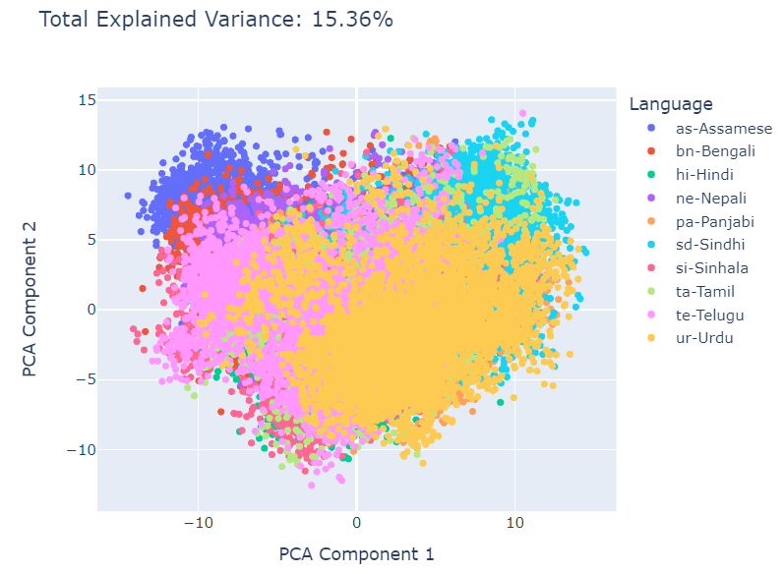
Fig 1. In-set Languages Visualisation using 2 PCA Components

- t-Distributed Stochastic Neighbor Embedding(t-SNE): t-SNE is another method for dimensionality reduction which preserves the local relationships between data points in the high-dimensional space. It starts by calculating the probability of a data point being selected as a neighbor of another point in the high-dimensional space. Similar to PCA we reduced our 256 feature array into 2 t-SNE components and tried projecting to find the language behaviour in 2-D space obtaining KL Divergence as 1.66%.
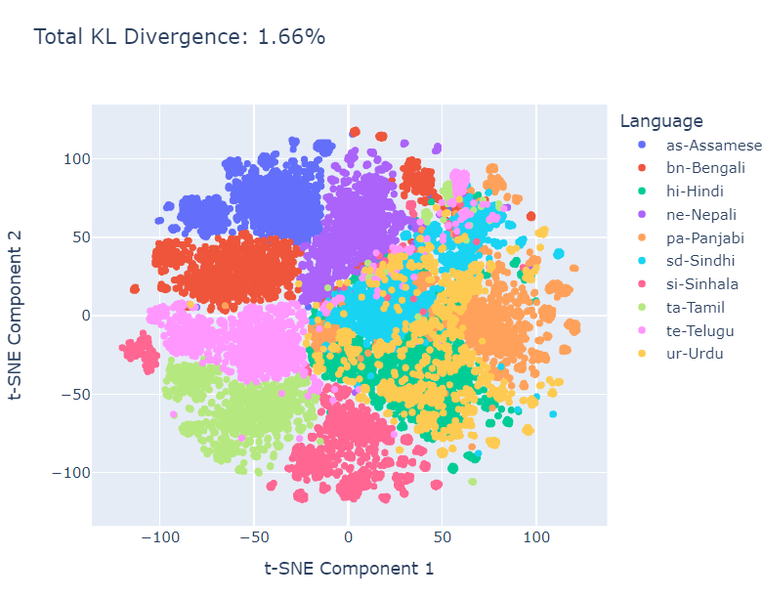

Fig 2. In-set Languages Visualisation using 2 t-SNE Components

6.2 Outlier Detection:
We address the challenge of identifying and handling outliers within the dataset, which can negatively impact model performance. To achieve this, we employ a one-class Support Vector Machine (SVM) for outlier detection. The one-class SVM is trained on features extracted from multilingual audio recordings, with dimensionality reduction techniques applied beforehand to enhance computational efficiency. We set a strict nu parameter (0.01) within the one-class SVM, prioritizing a model with minimal false positives (misclassifying known languages as outliers). By analyzing the distribution of outliers, we gain insights into potential data anomalies and language variations. This analysis is crucial for establishing language-specific anomaly thresholds. These thresholds define the expected feature variation range for each language within the reduced-dimensional space. Data points falling outside their corresponding language threshold are then considered strong candidates for OOS LIDs.

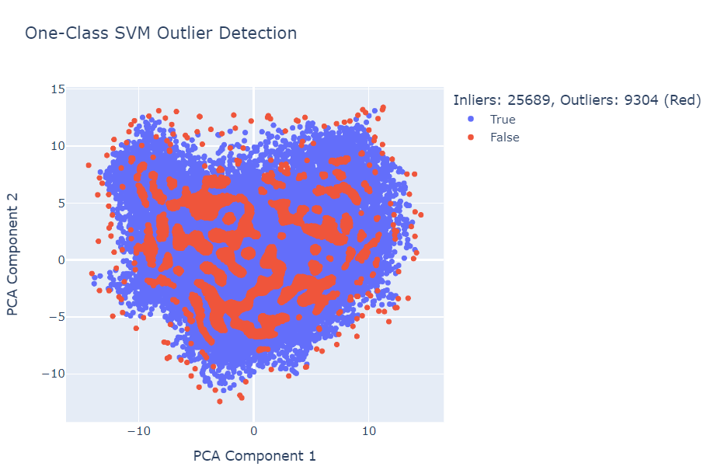
Fig 3. Outlier Dectection using PCA Components

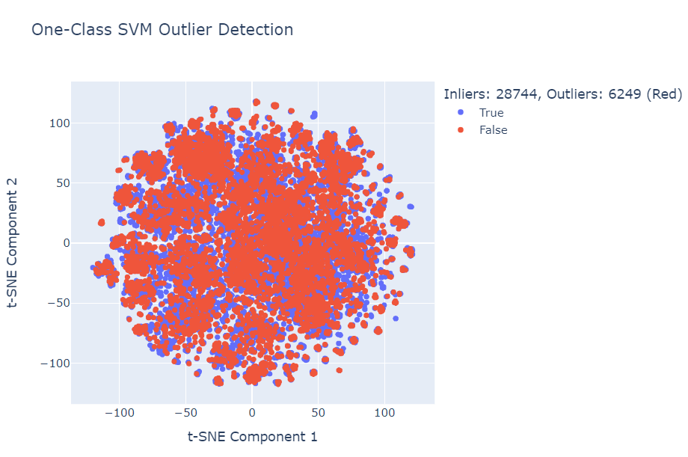

Fig 4. Outlier Detection using t-SNE Components
5.3 Training Classifier:
Following outlier detection and dimensionality reduction, we focus on classifying in-set languages (known lids) within the multilingual audio dataset. To achieve this, a supervised Support Vector Machine (SVM) classifier is employed. The in-set data is strategically divided into a 70/30 split, with 70% allocated for training the classifier and 30% reserved for testing its performance.
The trained SVM classifier outputs probability scores for each language. By analyzing these probabilities, we aim to establish a robust method for language identification. The abstract describes two key aspects of this analysis:
- Probability Range for Each Language: We investigate the range of probability scores typically associated with each language within the dataset. This provides valuable insights into the model's confidence in identifying different languages.
- Gaussian Distribution and Threshold Probability: The abstract suggests plotting the distribution of probabilities for each language, potentially using a Gaussian distribution as a model. This visualization can aid in identifying a threshold probability for each language. Data points with probabilities falling below this threshold would be considered less certain classifications, requiring further investigation or potentially indicating OOS lids. We find out threshold probability by subtracting the standard deviation of probabilities of languages by the mean probability of language.
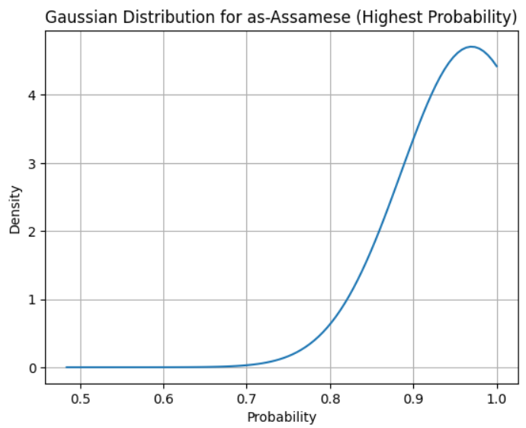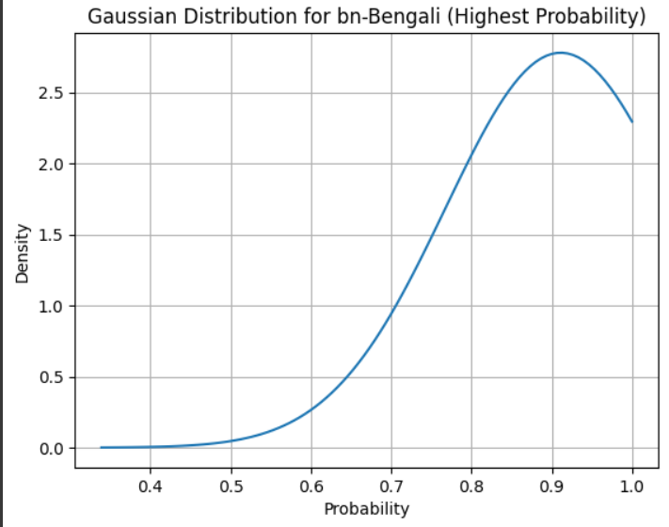
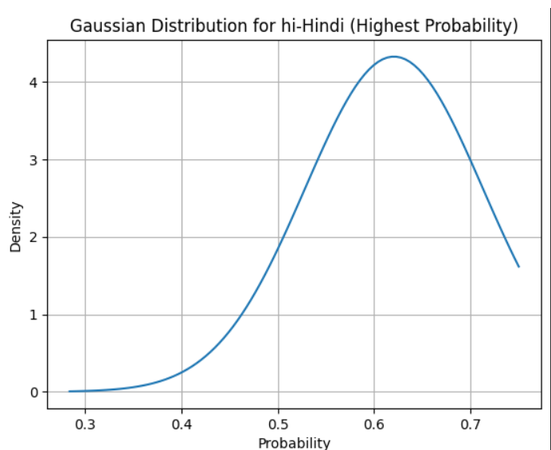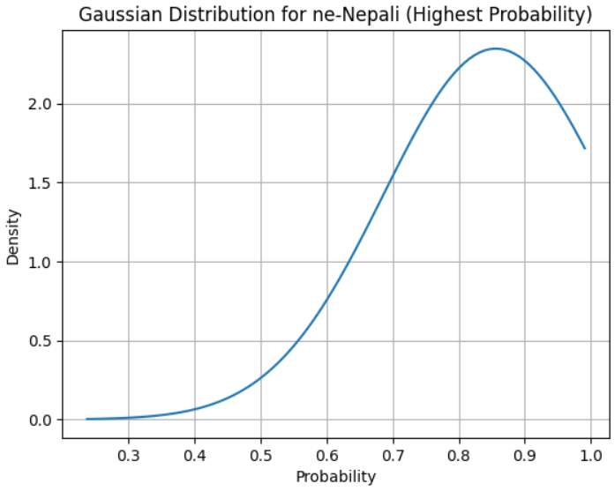
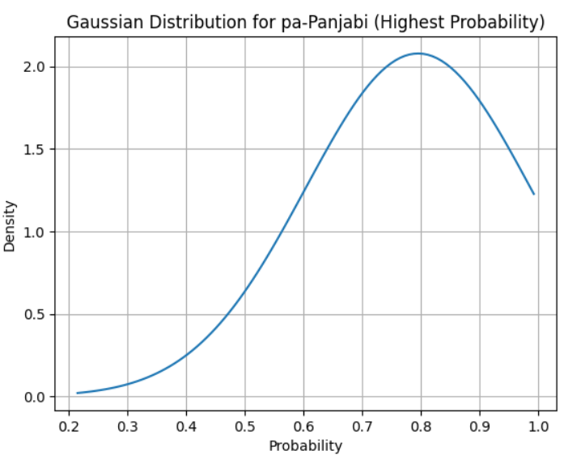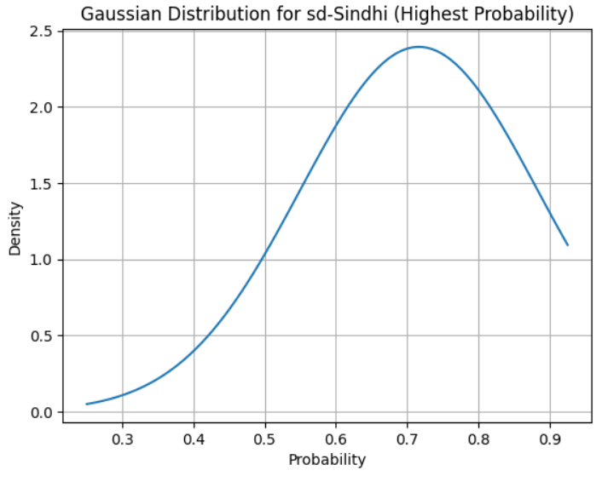
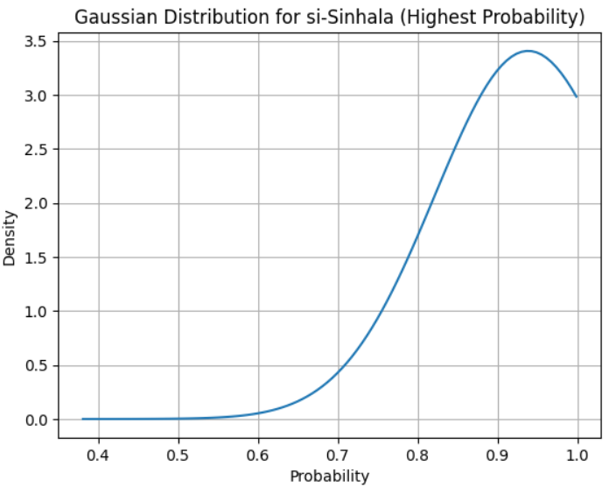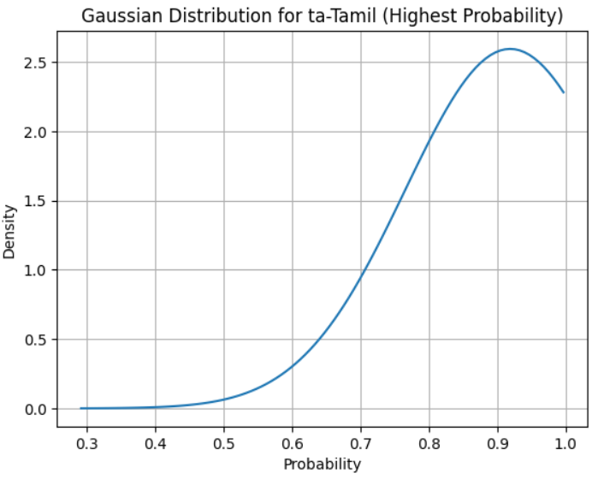
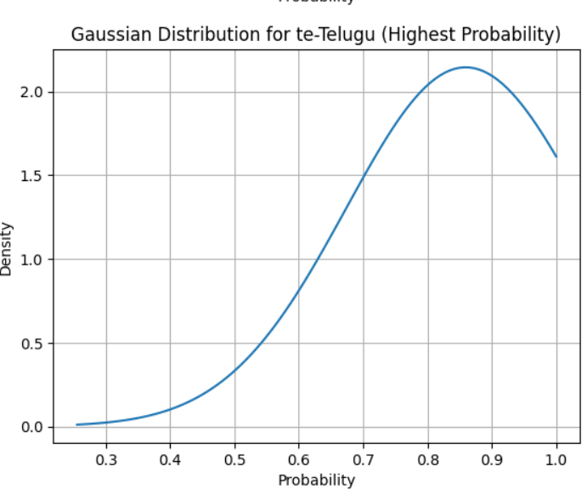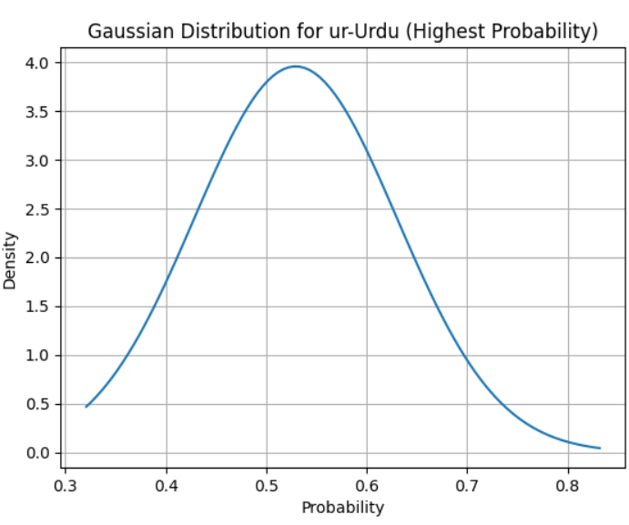
Fig 5. Gaussian Distribution for probabilities of each Language

When the testing data was passed to the trained classifier it achieved an accuracy of 99.8%.
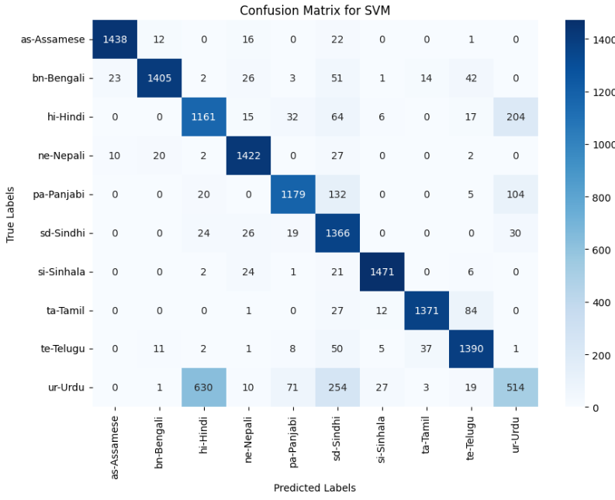
Fig 6. Confusion Matrix for Testing set.

- Results:
An SVM classifier, trained on a 70/30 split of in-set data, assigns probability scores to each language for a given audio sample. We establish language-specific thresholds based on these probabilities. During testing, we passed Out-set testing data, if the predicted probability for a language falls below its threshold, the sample is considered an outlier.
The following table shows the threshold probability for each In-set language.
Language | Threshold Probabilty
Assamese | 0.8849
Bengali | 0.7669
Hindi | 0.5323
Nepali | 0.6859
Panjabi | 0.6003
Sindhi | 0.5490
Sinhala | 0.8222
Tamil | 0.7659
Telugu | 0.6736
Urdu | 0.4283

Table 2. List of Languages and their Threshold Probability

When the Out of set was passed to the SVM Classifier, according to our defined threshold probability conditions, the classifier must predict each of the samples as Outlier as the data was not present in the training set.
The following tables shows no. of samples it classified as outliers out of 4999 samples provided for each Out of Set language.

Language | No. of Outliers
Arabic | 460
Tibetan | 997
English | 1004
Persian | 614
Indonesian | 884
Burmese | 796
Pushto | 584
Thai | 672
Vietnamese | 664
Mandarian | 1120

Table 3. Outset Languages with their no of Samples identifies as outliers

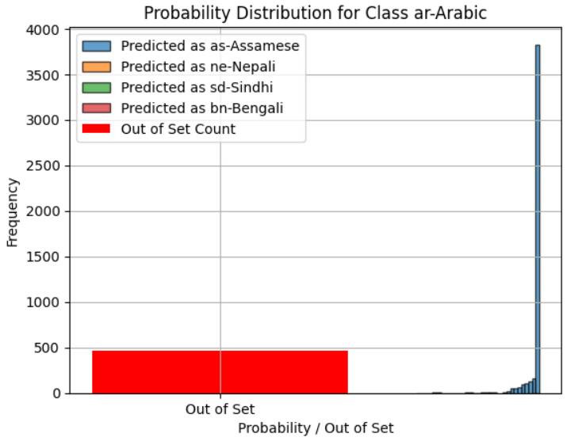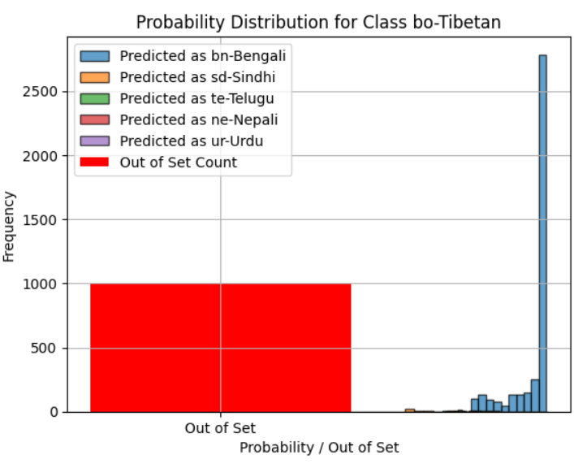

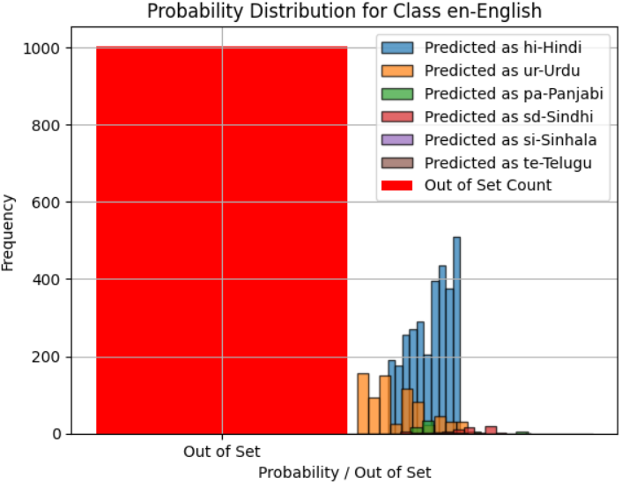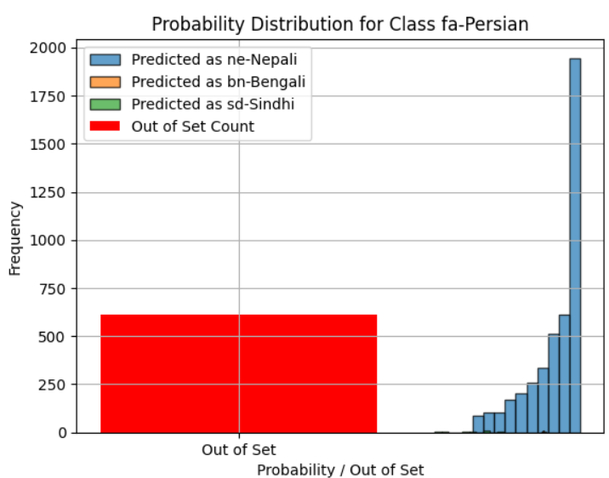

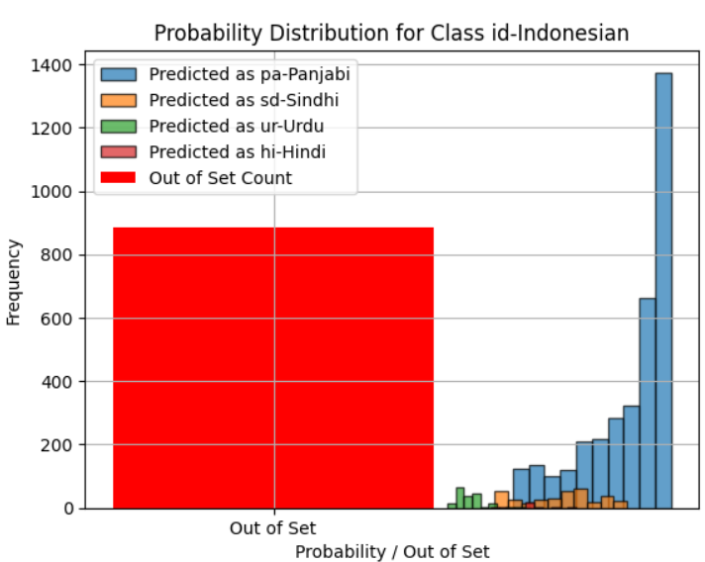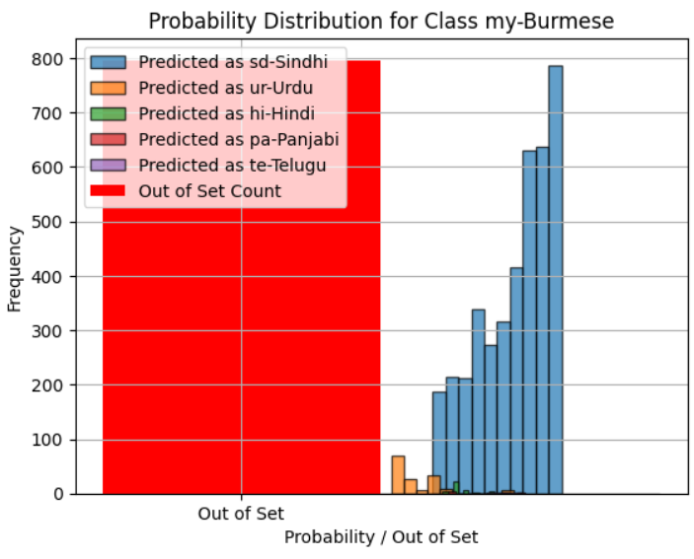

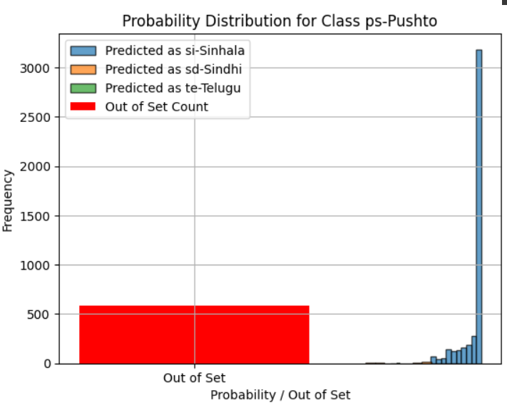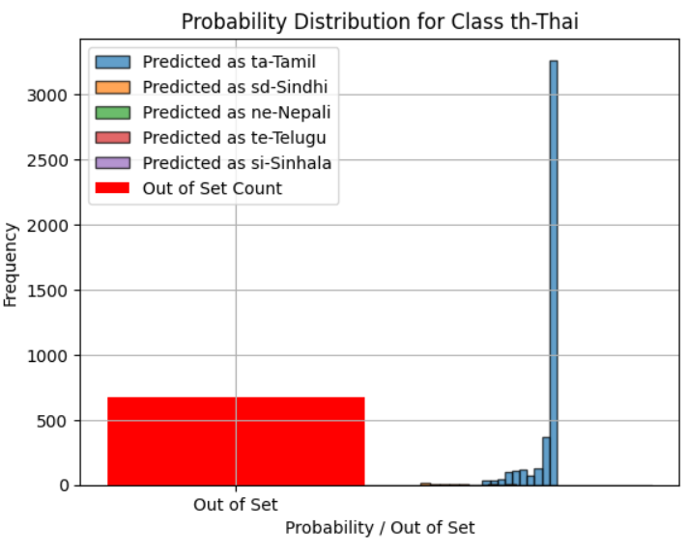

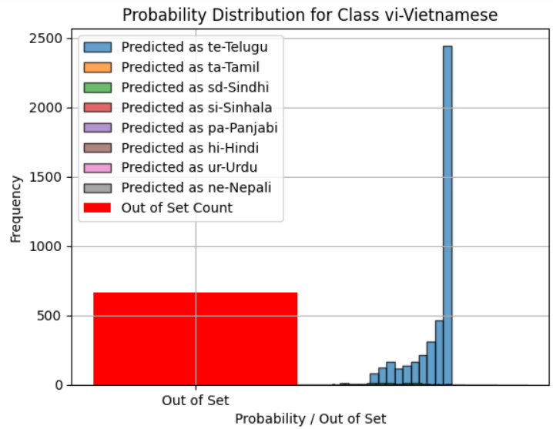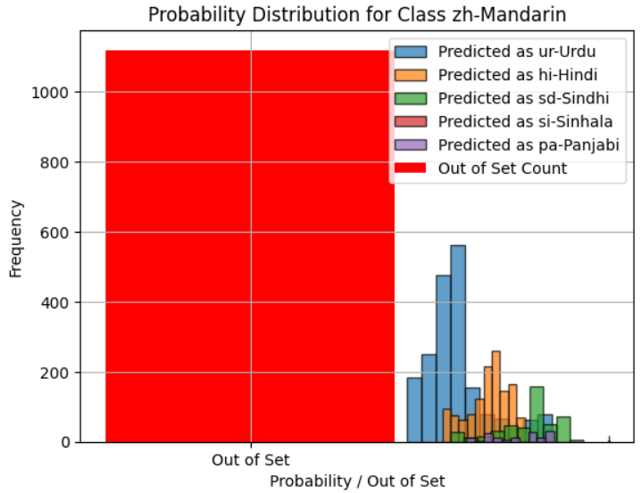

Fig 7. Probability Distribution for each Outset Language

From the above stated method of individual Language thresholding, we achieved an accuracy of 15.60%.
As we can see the languages like Tibetan and Mandarian achieved pretty good accuracy of 19.94% and 22.40% respectively as these languages have different features than the Indian Language.

- Conclusion and Future Work:
The current approach achieves a 15% accuracy in outlier detection, highlighting the need for further optimization.
Improved Probability Thresholding: We plan to explore advanced techniques for calculating language-specific thresholds. This might involve:
  - Ensemble Methods: Combining predictions from multiple classifiers (e.g., Random Forest, XGBoost) could potentially lead to more robust probability estimates.
  - Density-Based Thresholding: Techniques like kernel density estimation might aid in establishing more accurate thresholds based on the underlying probability distribution of each language.
Enhanced Dimensionality Reduction: We will investigate alternative dimensionality reduction methods beyond t-SNE. Techniques like:
  - Uniform Manifold Approximation and Projection (UMAP): UMAP might offer superior preservation of local data structure, potentially leading to a more informative low-dimensional representation for outlier detection.
  - Autoencoders: Autoencoders can be used for dimensionality reduction while learning a compressed representation that captures essential language features.
Evaluation Metrics: We will incorporate more comprehensive evaluation metrics beyond accuracy, such as precision, recall, and F1-score, to provide a more nuanced understanding of the outlier detection performance.
Significance:
This work demonstrates the potential of using language probabilities and dimensionality reduction for outlier detection in OOS-LC. By exploring advanced algorithms for thresholding and dimensionality reduction, we aim to develop a more robust framework for identifying outliers and ultimately enhance the performance of the OOS-LC system in distinguishing known languages from unseen lid types.

